PHP Server Files

Contents

AddGame.php 2

GeneralQuery.php 2

MyGamesQuery.php 3

PasswordQuery.php 3

Query.php 4

TopTenQuery.php 5

UninstallQuery.php 6

UpdateAccountQuery.php 7

WriteAccountQuery.php 8

# AddGame.php

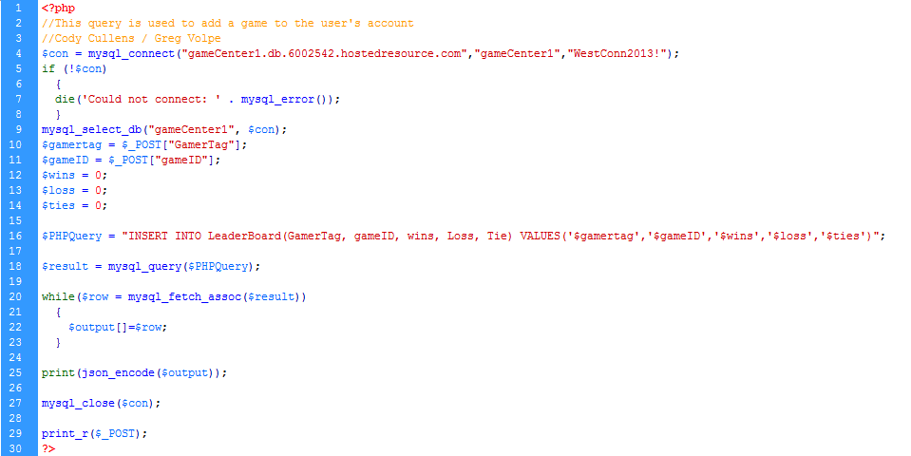

# GeneralQuery.php

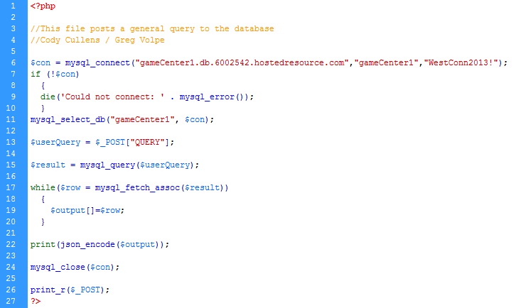

# MyGamesQuery.php

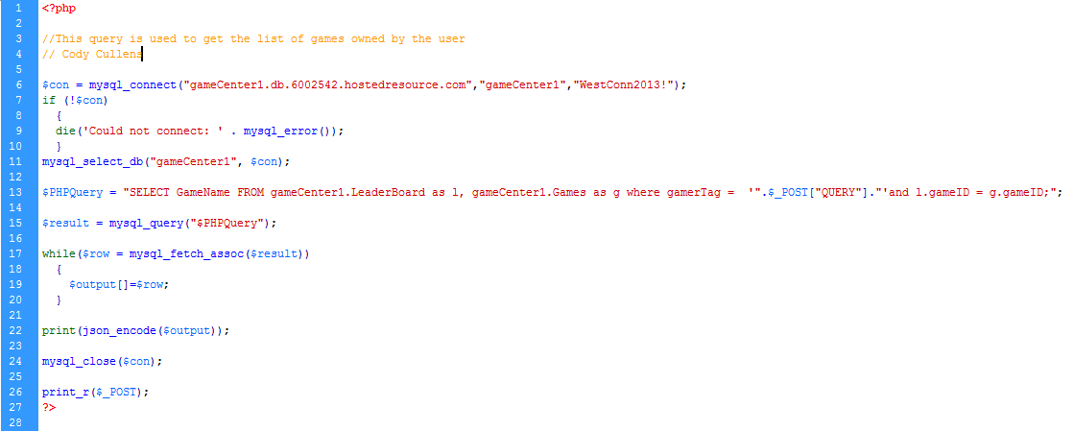

# PasswordQuery.php

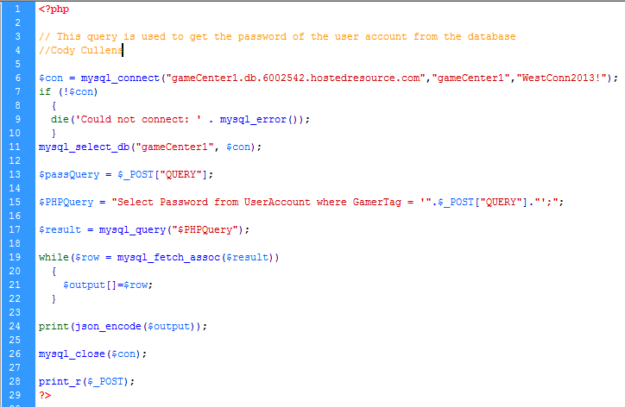

# Query.php

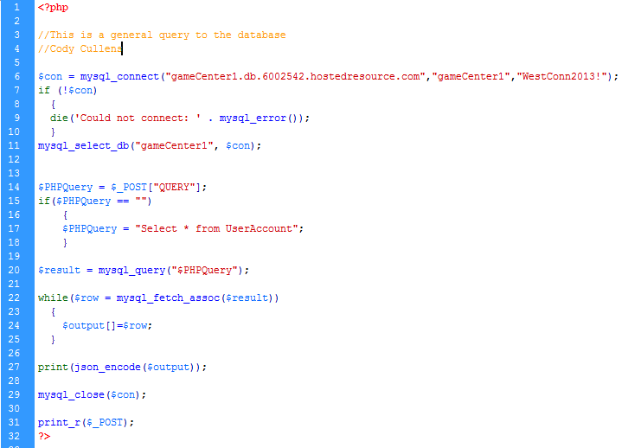

# TopTenQuery.php

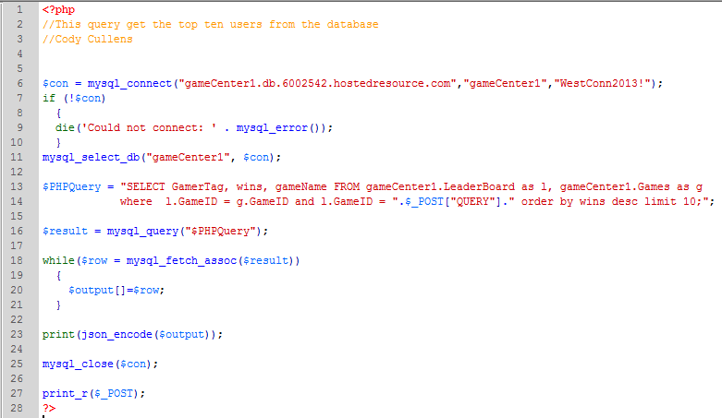

# UninstallQuery.php

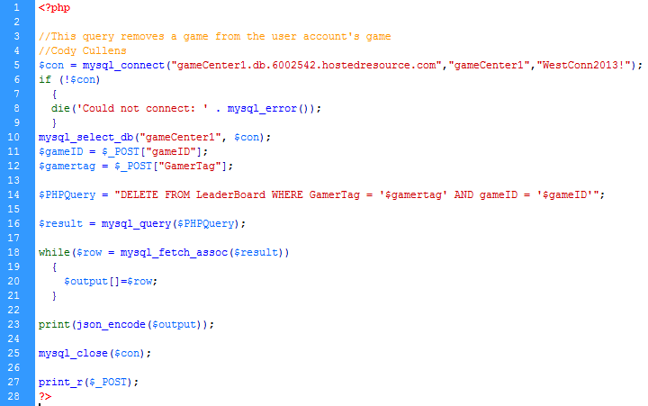

# UpdateAccountQuery.php

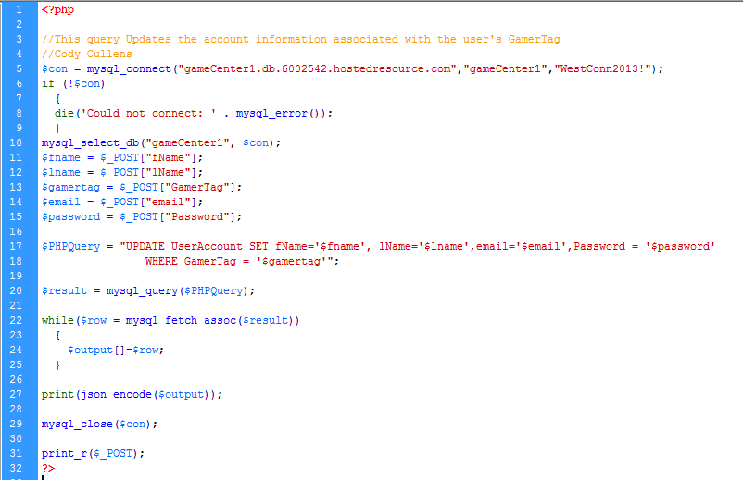

# WriteAccountQuery.php

